**ERD to RD**

**Câu 1**

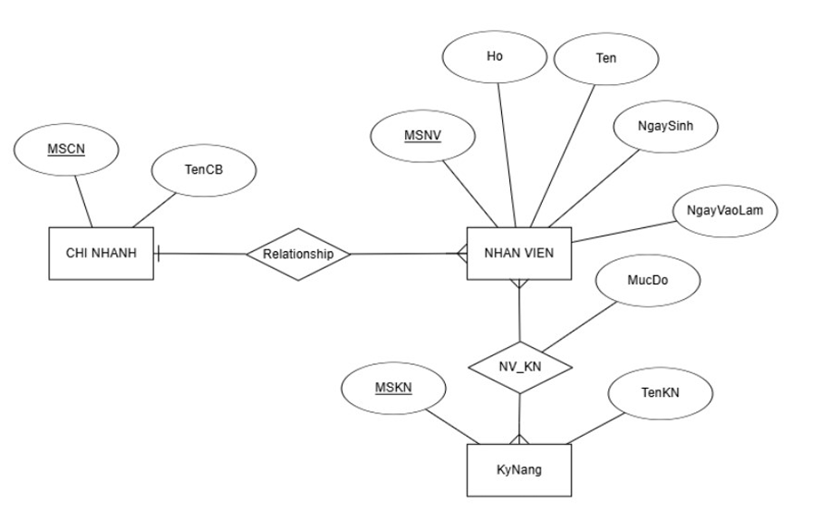

**Câu 2**



